**Question 37 (2016 Sem II Paper) (14 marks)**

Scientific evidence shows that the physical and behavioural traits shared by all modern humans originated from apelike ancestors. It is believed that *Ardipithecus ramidus* was an early ancestral

hominin living approximately 4.5 million years ago in what is now known as Ethiopia.

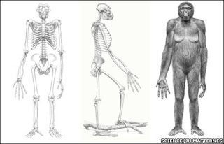

1. *Ardipithecus ramidus* has characteristics of both apes and humans. Describe **two (2)** pieces of evidence that suggests *Ardipithecus ramidus* could have been bipedal. (4 marks)

__________________________________________________________________________________________________________________________________________________________________________________________________________________________________________________________________________________________________________________________________________________________________________________________________________________________________________________________________________________________________________________________________________________________________________________________________________________________________________________________________________________________________________________________________________________________

1. Four of the main hominid tool cultures are Oldowan, Acheulean, Mousterian, and Solutrean. Describe at least **two (2)** of the trends (design, manufacture, or material) in the tool cultures over time. (4 marks)

Trend One: ­­­­­­­­­­­­­­________________________________________________________________

___________________________________________________________________________________________________________________________________________________________________________________________________________________________

_________________________________________________________________________

Trend Two: ­­­­­­­­­­­­­­________________________________________________________________

___________________________________________________________________________________________________________________________________________________________________________________________________________________________

_________________________________________________________________________

1. Fossil remains of *A. afarensis* discovered in the 1970’s show that bipedal locomotion evolved before changes occurred in the skull. State the trend in cranial capacity between lemurs, monkeys, chimpanzees and humans, and describe an advantage of this trend. (3 marks)

___________________________________________________________________________________________________________________________________________________________________________________________________________________________

__________________________________________________________________________________________________________________________________________________

__________________________________________________________________________________________________________________________________________________

1. Explain how mitochondrial DNA provides evidence for human evolution. (3 marks)

___________________________________________________________________________________________________________________________________________________________________________________________________________________________

__________________________________________________________________________________________________________________________________________________

__________________________________________________________________________________________________________________________________________________

**Question 39 (2016 Sem II Paper) (20 marks)**

The vertebral column of humans is designed to support the weight of the head and torso with minimum use of energy. This trend of S-shaped spines was noted in the earliest Australopithecines, and is a significant feature associated with bipedalism.

1. Name the **two (2)** curves that are found in the S-shaped spine, and state how they contribute to an upright stance. (4 marks)
2. Alongside skeletal changes, there has been a trend of increasing cognitive abilities and lifestyles with human evolution. Describe the significance of tool development and use for hominin evolution.

(8 marks)

1. A new genetic study has revealed that genes inherited from Neanderthals 50,000 years ago have played a key role in our immune system today. Describe the events that occur in the humoral immune response and explain how the effects of invading microorganisms are overcome.

(8 marks)

**Question 32 (2015 Sem II Paper) (13 marks)**

Part (a) of the question refers to the tool diagrams A, B, C and D shown below.

**A B C D**

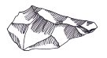 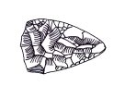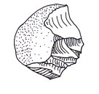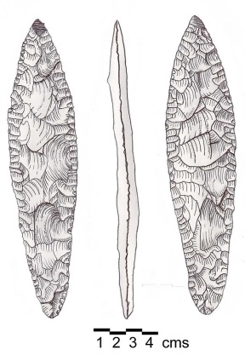

1. Complete the table below by placing the tools A, B, C and D in the correct evolutionary sequence, from oldest to most recent. Include the hominin species it is associated with.

(4 marks)

|  |  |  |
| --- | --- | --- |
| **Letter –**  **A, B, C or D** | **Name of Tool Culture** | **Used by** |
|  | *Oldest* |  |
|  |  |  |
|  |  |  |
|  | *Youngest* |  |

1. Hominin tool culture has distinctly changed over time.

List **one** trend relating to (2 marks)

1. manufacture – ________________________________________________________ ________________________________________________________________________________________________________________________________________
2. use – _______________________________________________________________ ________________________________________________________________________________________________________________________________________
3. It is believed that tool use became possible with the transition to bipedalism.

Explain an adaptation for each biological structure that could have led to the evolution of bipedalism. (4 marks)

|  |  |  |
| --- | --- | --- |
| **Structure** | **Adaptation** | **How this assists bipedal movement** |
| Foot |  |  |
| Hip Joint |  |  |

1. Hominin skulls exhibit many changes though time.

State **three** evolutionary trends evident in hominin skulls. (3 marks)

____________________________________________________________________________________________________________________________________________________________________________________________________________________________________________________________________________________________________________________________________________________________________________________________________________________________________________________________

**Question 33. (2014 Sem II Exam) (13 marks)**

a) Describe the general trend in the evolution of human teeth and describe cultural factors that may have influenced this trend. (3 marks)

________________________________________________________________________________

________________________________________________________________________________

________________________________________________________________________________

________________________________________________________________________________

b) i) Describe three selection pressures that may have led to the development of bipedalism in early hominids. (3 marks)

________________________________________________________________________________

________________________________________________________________________________

________________________________________________________________________________

________________________________________________________________________________

ii) What features of a fossilised skeleton would clearly indicate the individual was bipedal?

(3 marks)

________________________________________________________________________________

________________________________________________________________________________

________________________________________________________________________________

________________________________________________________________________________

c) The primate pictured below is a ring-tailed lemur from Perth Zoo. In each box, briefly describe the general features of all primates: (4 marks)

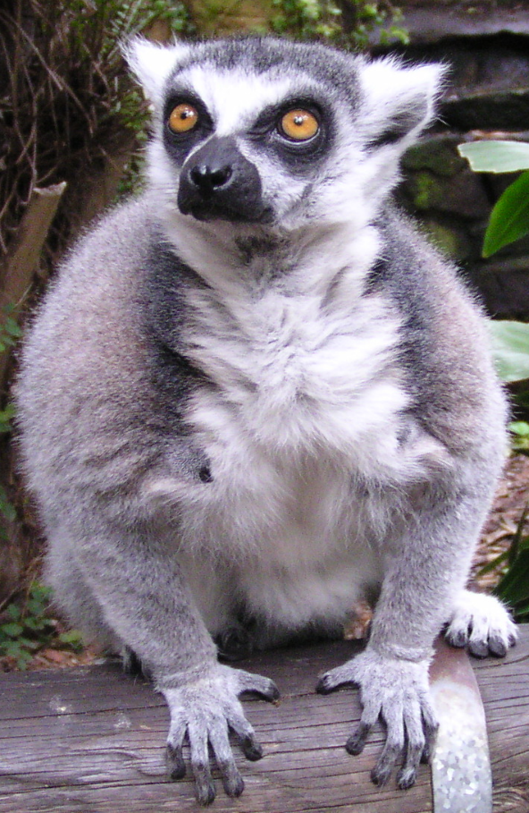

Brain

Vision

Reproduction

Hands